

**SEMESTER III – Flutter and Java project**

Topic: E-Commerce Application

**USER’S DOCUMENTATION**

Table of contents

* Table of contents
* Introduction to CurrenSee
* Breakdown of the App’s functions
* Step-by-step guide on how to navigate the app
* App requirements and restraints
* FAQ’s and answers

INTRODUCTION TO CURRENSEE

CurrenSee is an e-finance application developed for ABC ltd to meet the financial needs of its users. Individuals, businesses, families and travelers alike can use the features to set preferences, meet their various needs and give feedback about their problems and experiences. With information from dozens of trusted sources, CurrenSee allows users to convert and monitor currencies and exchange rates free of charge. It is not perfect yet, but always improving with help from it’s users in the form feedback and support available 24/7.

BREAKDOWN OF THE APP’S FUNCTIONS

The app allows users to log or sign in, change account details, convert currencies, see live and past rates, see articles on the latest market exchange trends, choose a default currency, and contact the developer.

STEP-BY-STEP GUIDE ON HOW TO NAVIGATE THE APP

Once the app has loaded, the user(s) will be taken to the landing page where they have three buttons each with different functions.



* The first button is the green “Sign Up” button. When it is clicked, it takes user(s) to the Signup page:

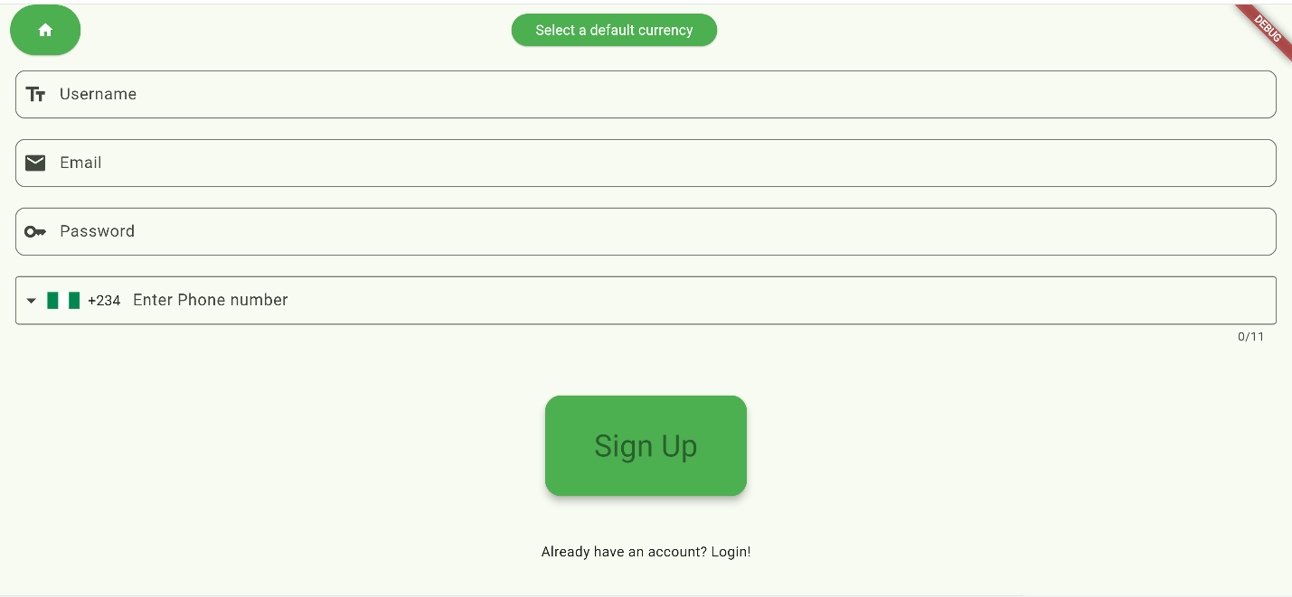

* At the Signup page, there are two buttons at the top of the page, four input fields at the middle, a button near the bottom and a link at the bottom

1. The first button is a green home button with a house icon on it:

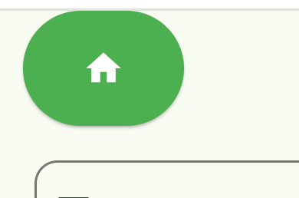

Clicking on the button will direct user(s) back to the landing page.

2. The second button allows user(s) to choose their default currency

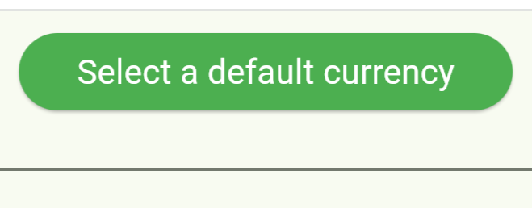

When it is clicked a popup shows a searchable list where user(s) can pick their desired base currency. When the user selects a currency, the list disappears and the text on the button changes to include the country code for the currency they choose. Whatever currency they choose will be the default for the account

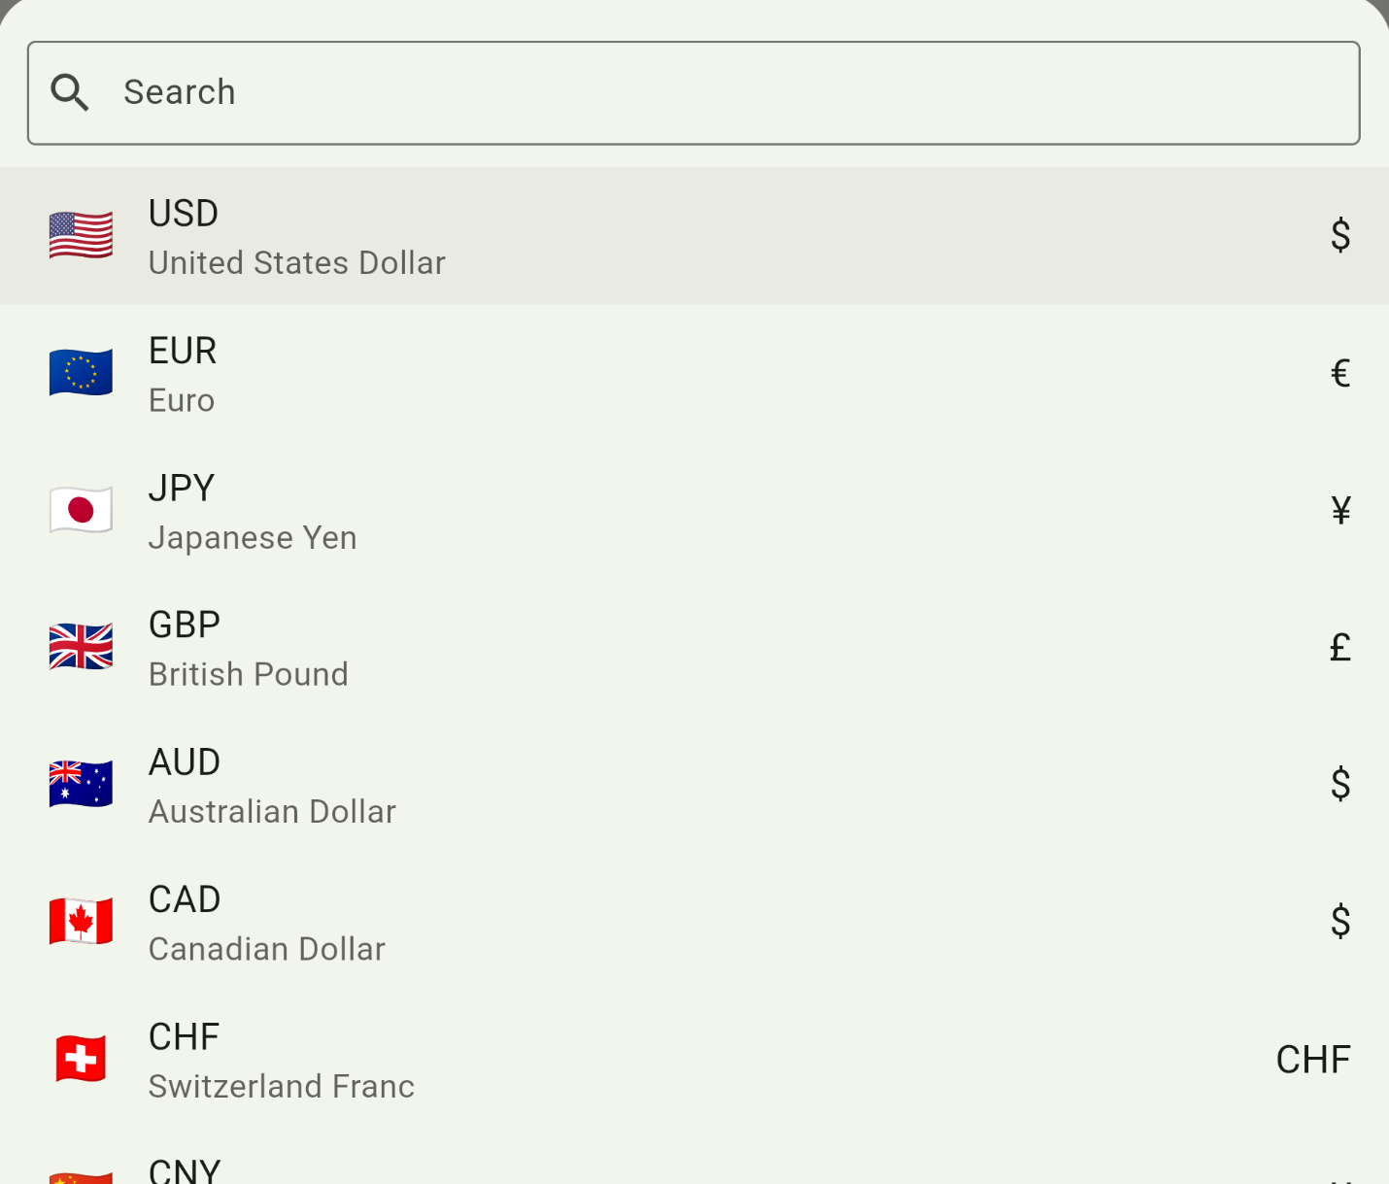



3. --- The four input fields from top to bottom are the username, email, password and phone number fields.

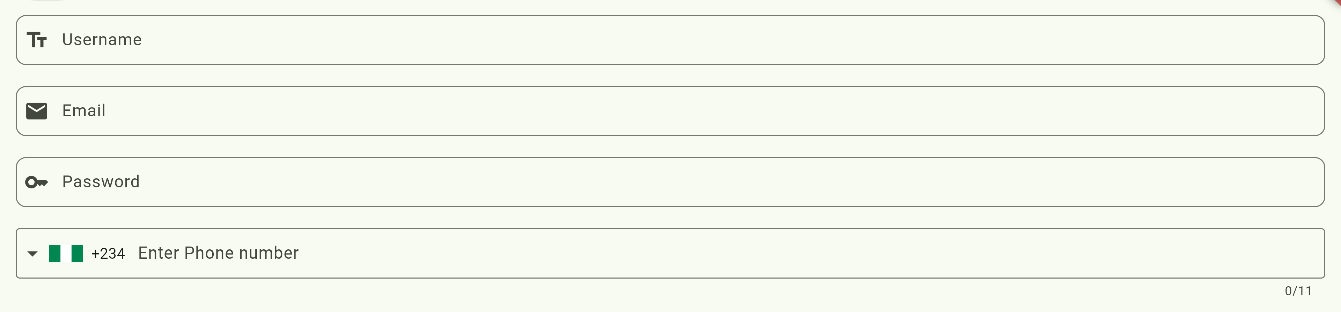

The first three fields accept text inputs with different requirements. The username field cannot accept spaces, because usernames are not allowed to have spaces. The text in the email field must be in the format of a standard email, and the password field must have at least 8 characters, with at least one character being a special one. If the inputs don’t meet the requirements, each field will show an error message of its own.

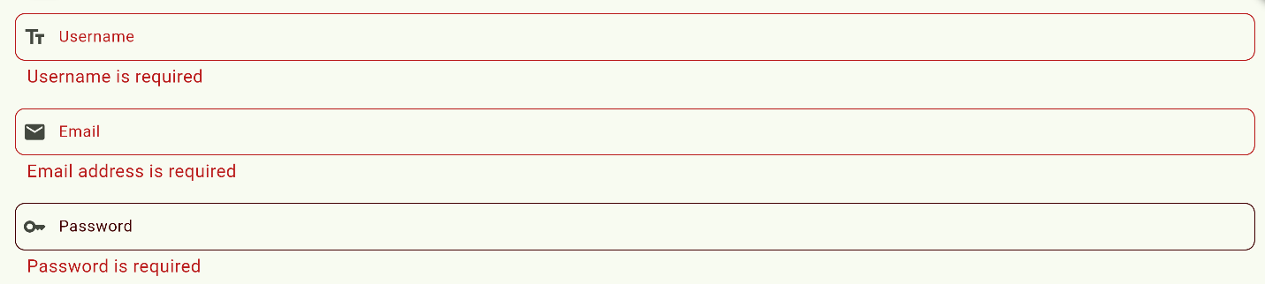

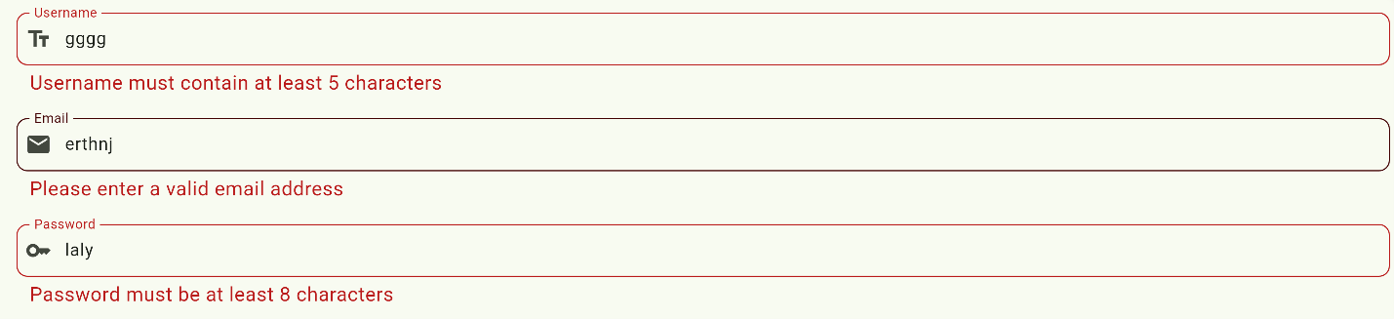



--- The phone number field, unlike the other three fields only accepts numbers. It is embedded with a searchable list of various iso-codes for numbers of different regions

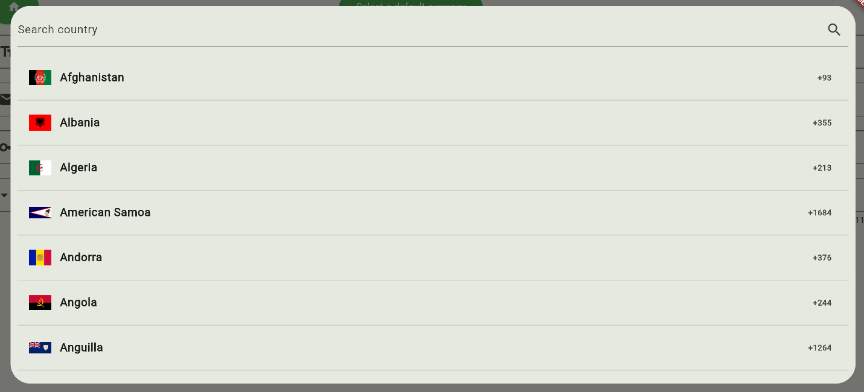

Once the user selects a country code, the flag, number and input limit change according to the corresponding country’s average number of phone number digits.

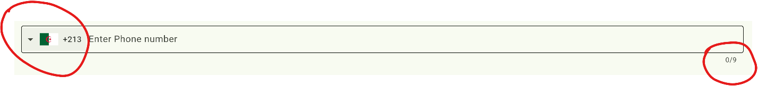

The user has to enter the correct amount of digits for the country’s phone number to avoid this error.



When the user inputs all the required information, they can click the 4. Sign up button to create an account and proceed to the home page.



5. The link at the bottom of the page, as it’s text suggests navigates the browser window to the login page for users who already have an account.



* When clinking the link, or the yellow “Login” button on the landing page, the user is directed to the login page.
* The login page is similar to the sign up page, but instead consists of one button at the top, two input fields at the middle, the login button and a link both near the bottom,

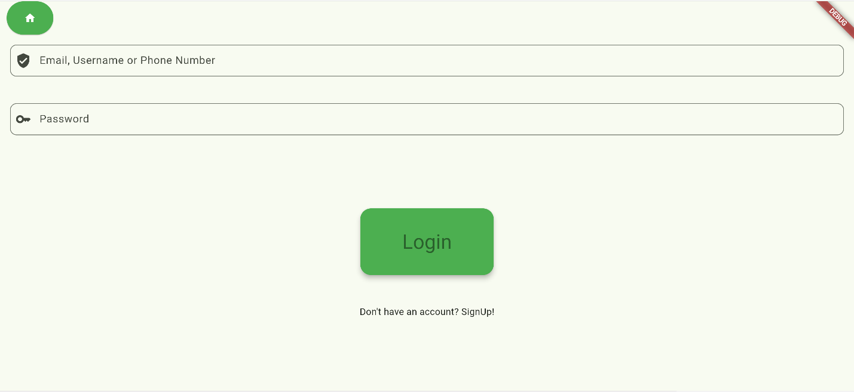

1. The button at the top looks and functions just like the home button on the sign up page.

2. -- The first of the two input fields allow the user to enter any one of: their email, their username or their phone number with country code included. Whichever value the user chooses to enter will be used along side their password to identify their account information.

-- The second field requires the password for the user’s account and functions just like the password field of the sign up page.

If the user enters incorrect password, username, phone number or email, the following error message is displayed. [ The link at the bottom will take the user to the sign up page ]



But if the information is correct, the user will proceed to the home page.

* The third button on the landing page is the red “See home page as guest” button. When it is clicked, the user is directed to the home page without an account, but they can only convert currencies and see the list of supported currencies, as anything else will redirect them to the signup page.

Home Page:



The home page consists of an app bar with three icons and six buttons with different actions.

* The first icon on the app-bar will carry the country code of the users default currency. When clicked it will show a list identical to the one of the signup page. If the user selects a different currency instead of clicking away to exit the list, The text on the icon will change to the country code of their default currency. e.g.:



* When clicked, the other two icons will bring out a sidebar with options

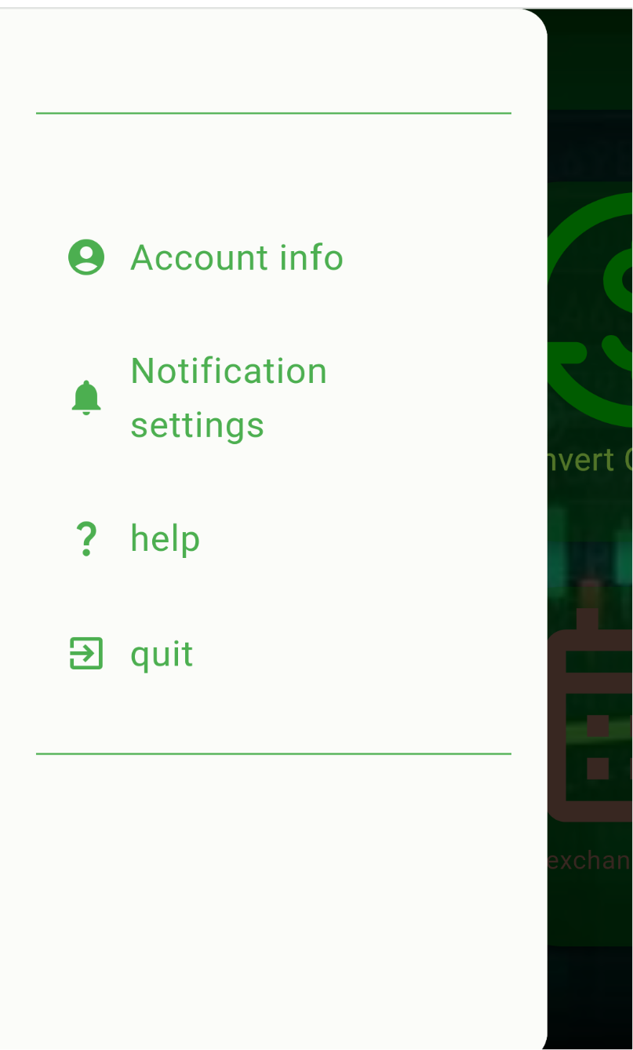

1. The “account info” option will direct the user to a page nearly identical to the sign up page, except it lacks the default currency button and the link. The “Sign up” button is now a “Change details button”. Leaving any field blank will result in the previous value being maintained. (unimplemented)

2. The “Notifications settings” option will allow users to configure notification settings and get alerts on their favorite articles and popular trends in rates (unimplemented)

3. The “Help” option displays a textbox with some instructions

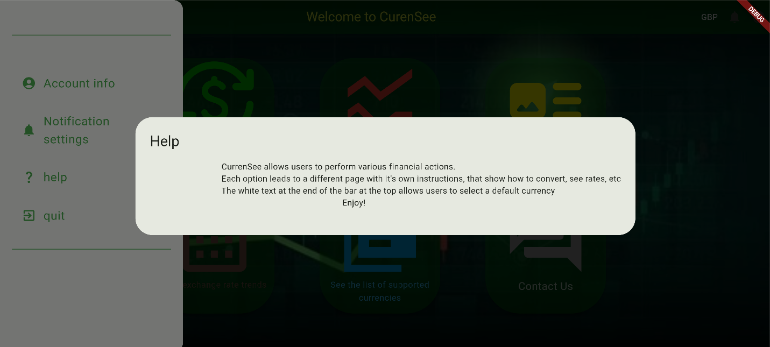

4. The “quit” option displays a dialogue

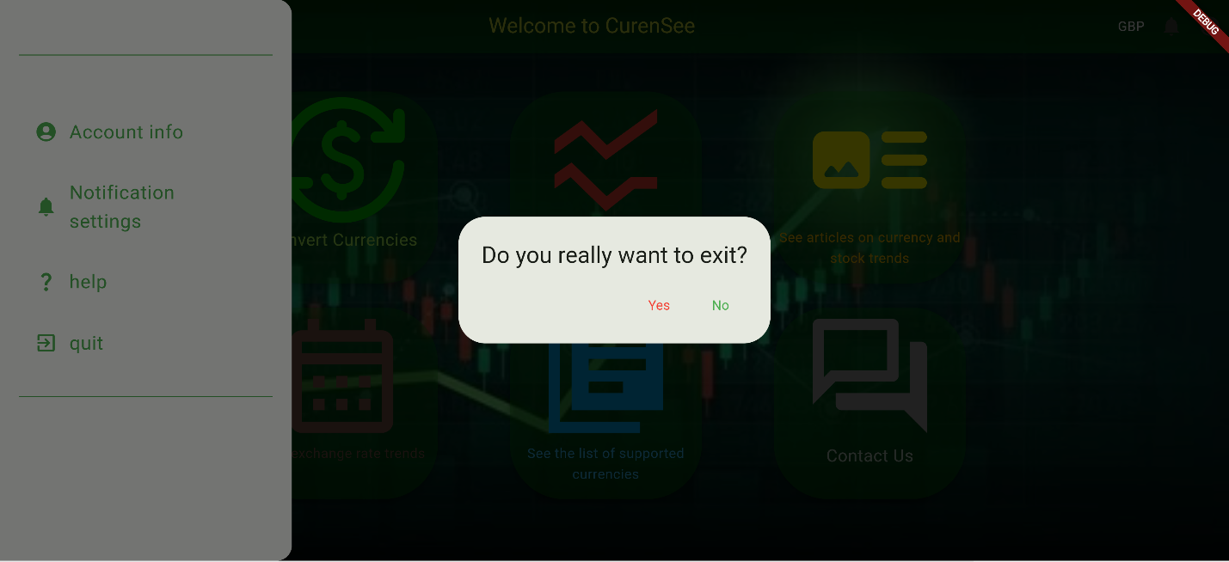

Clicking on “No” will exit the dialogue, while clicking on “Yes” will log the user out of their account and send them back to the landing page.

* The first of the six buttons is the green “Convert currencies” button works whether the user has an account or not. When clicked it directs the users to the convert page



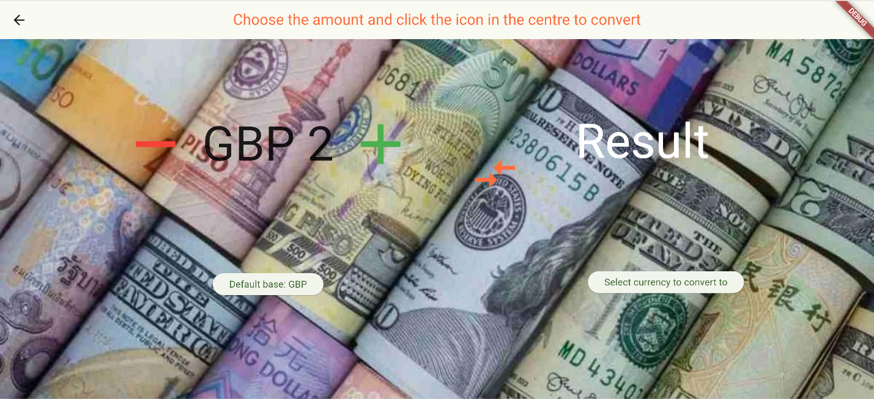

The convert currency page consists of an app-bar, four buttons and two display areas.

-- The first two buttons are in the first display area. Their purpose is to increase or decrease the amount of selected currency the user wants to convert.

-- If the user isn’t logged in, the first button will prompt the user to select a base currency. If they are it will display their base currency.

The user must use the buttons to enter an amount and choose a target currency(or both a base and target currency if they aren’t logged in) BEFORE clicking the button in the middle of the page to see their result.

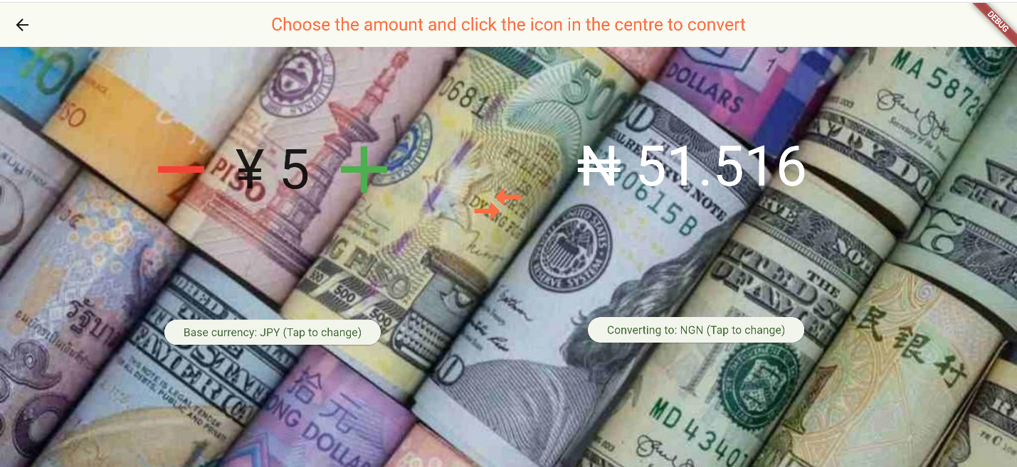

* The second button is the red “See exchange rates” button.

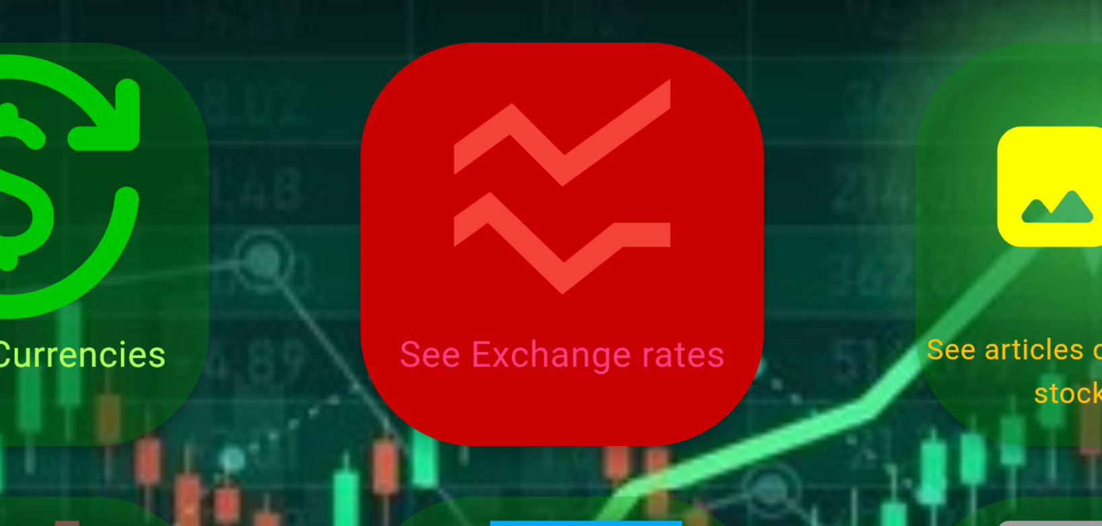

Clicking on it direct the user to an external exchange rates page. Similar to the convert page, the user chooses a base and target currency. They can then click the “View charts” button and scroll down to see a live chart

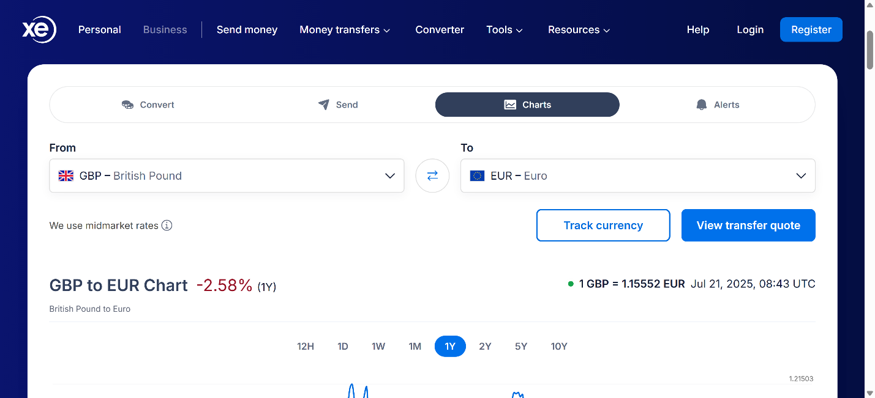

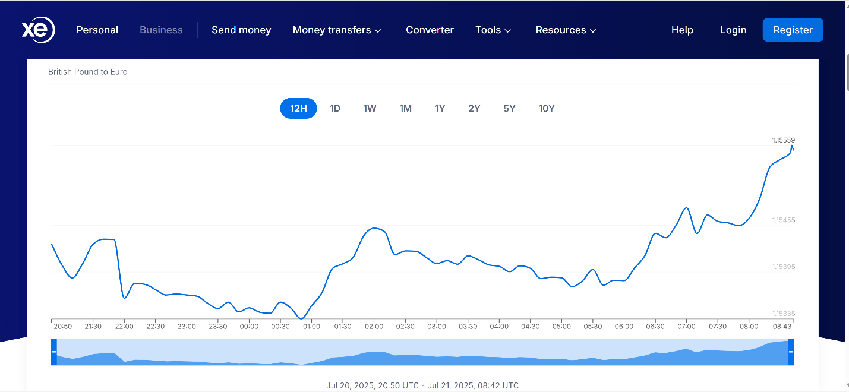

* The third button is the yellow “See articles on currency and stock trends” button. After clicking it, the user will have a chance of being directed to 1 out of three websites where some of our trusted sources write and publish the lates articles on the currency exchange market.



One of our trusted sources:



* The fourth button is the brown “Past exchange rate trends” button

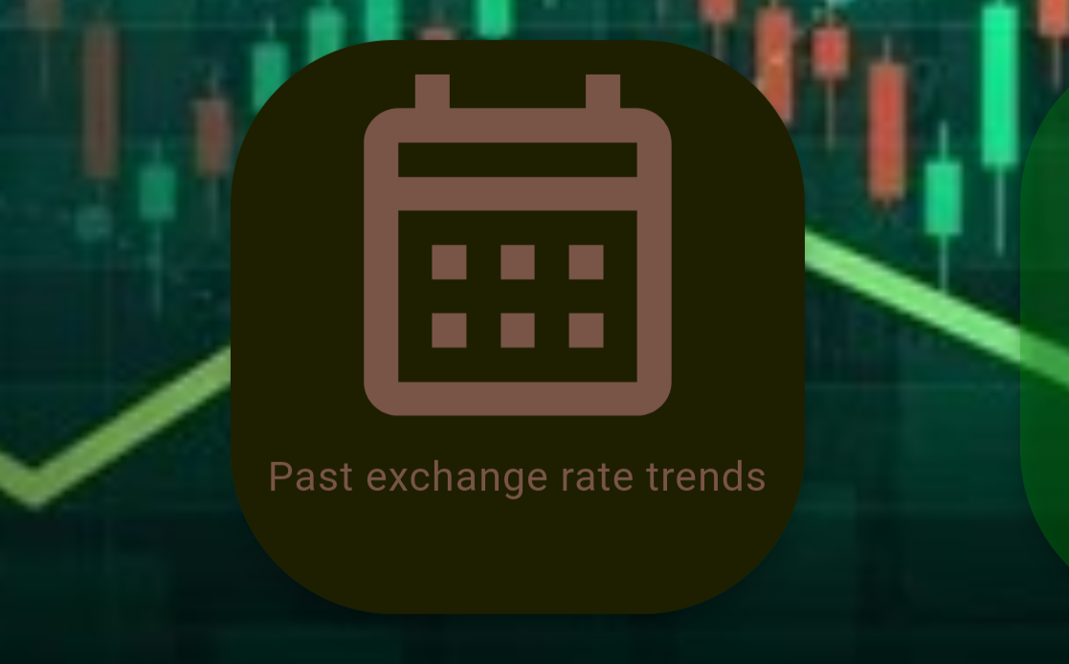

After clicking it, the user will be directed to an external site where they can see past exchange rates overtime by selecting a base and target currency along with a desired date and time range.

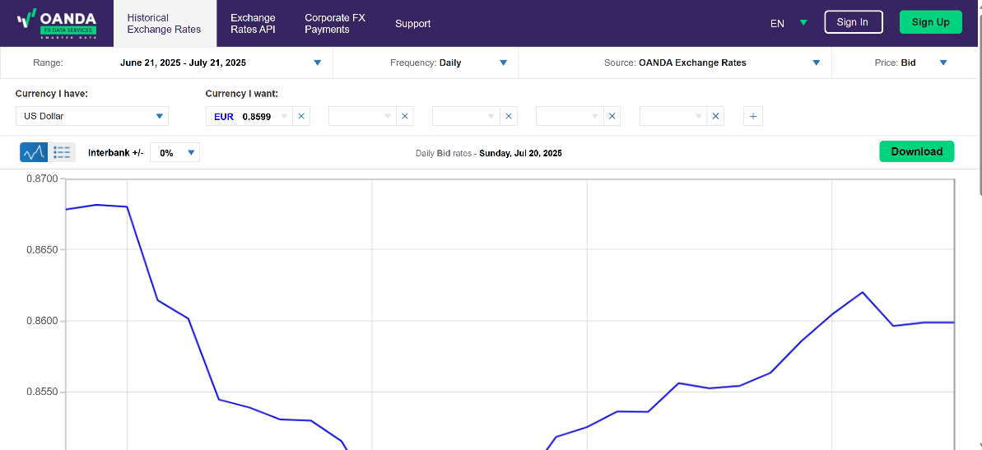

* The fifth button is the blue “See list of supported currencies” button



Clicking on it will bring a searchable list identical to the ones base currency icon and signup page. The only difference is that this list is not selectable. The user must click outside the list to exit it.

* The last button is the grey “Contact us” button. When clicked, it directs users to the contact page



The contact us page is simple, with just a text field and button. The user can type any questions or suggestions they have and click the “Send message” button. This will send what the user typed as an email from the user’s email address to the developer’s and send them back to the home page . Note that emails should be between 100 and 500 words long if not it will automatically get deleted before reaching our team.

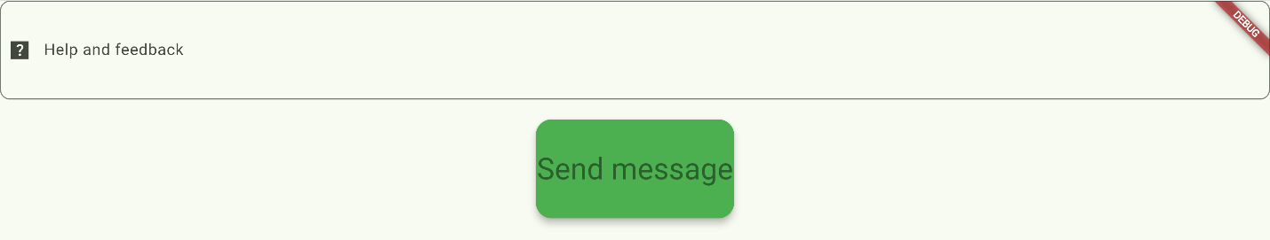

APP REQUIREMENTS AND RESTRAINTS

For CurrenSee to properly function, users will **require a stable and consistent internet connection** as anything else will cause lags with some features and failure to retrieve data from our databases and APIs, which the app needs to run.

The user will also need a newer **device (5 years or less for an iOS device, Android 10 or more for android and Windows 10 or more for windows)** **with sufficient memory and at least 2GB of storage** left for the app to properly function.

FREQUENTLY ASKED QUESTIONS AND ANSWERS

1. Q: Why does CurrenSee have so many links to external sites?

A: Right now, CurrenSee is in its infancy stage. It relies on the help of our trusted sources to perform some of the more complex functions for now. But it won’t be long before our developer updates the app to the point where it can perform those functions on its own.

2. Q: Why do some features do nothing?

A: It can be a lag. Sometimes when a user’s internet connection is unstable, some features may not load properly. The only features that genuinely do not work are some options on the app-bar, which is something that is being fixed as you are reading this.

3. Q: I am having trouble with my account. What should I do?

A: If you are having trouble signing up, it is due to incorrect information and the sign up page will tell you what you need to do. If you are having trouble logging into your account, you can contact our team at [ABC.ltd.org/currenSee](mailto:okpetaofure@gmail.com) with your issue and any information about the account that you have and our team will take care of it.

© 2025 ABC ltd, Aptech Computer Education. All Rights Reserved.